**Optimizing user, group and role management with access control and work flow**

**Team Id : NM2025TMID18883**

**Team Leader: VARSHA.M**

**Team member 1:** SANGEETHA. K

**Team member 2:** MITHIRA. A

**Team member 3 :** VALARMATHI. S

**Problem statement:** To create user , group and role along with access control.

**Objective:** The project is all about to create users , groups , tables and also roles along with access control . Also to create work flow.

**Skills:** learned to create user, group, tables and roles also their access control.

**TASK INITIATION**

**Milestone 1 :** Users

**Activity 1 :** Create Users

1. Open service now and select All
2. All > Users
3. Select user under system security and then select new
4. Provide required details about the user and click on submit
5. Again Create another user and again click on submit

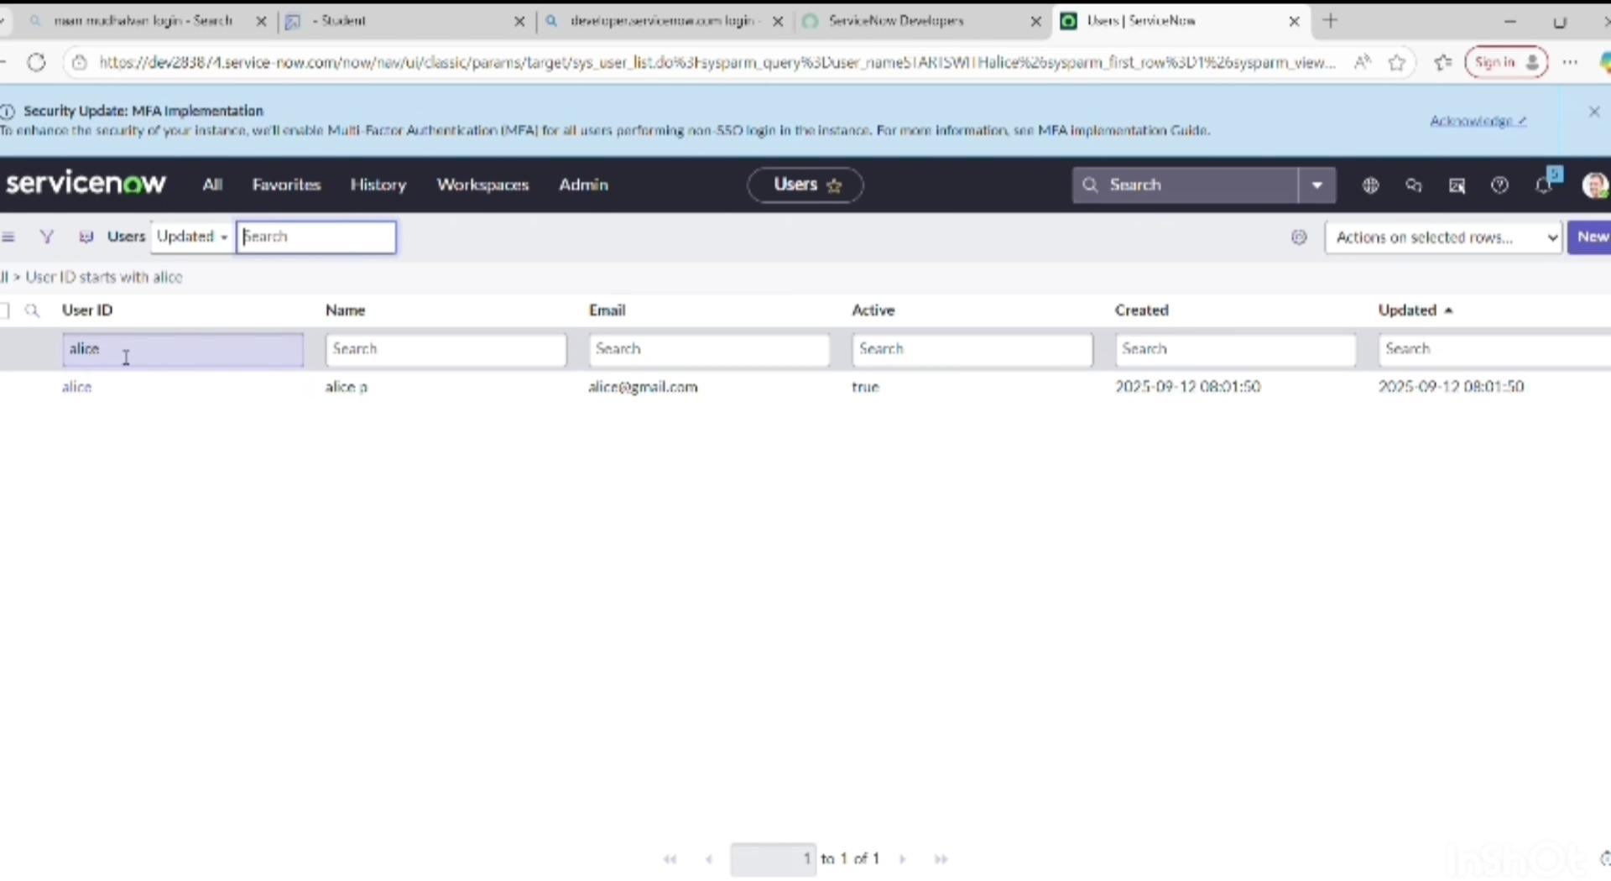

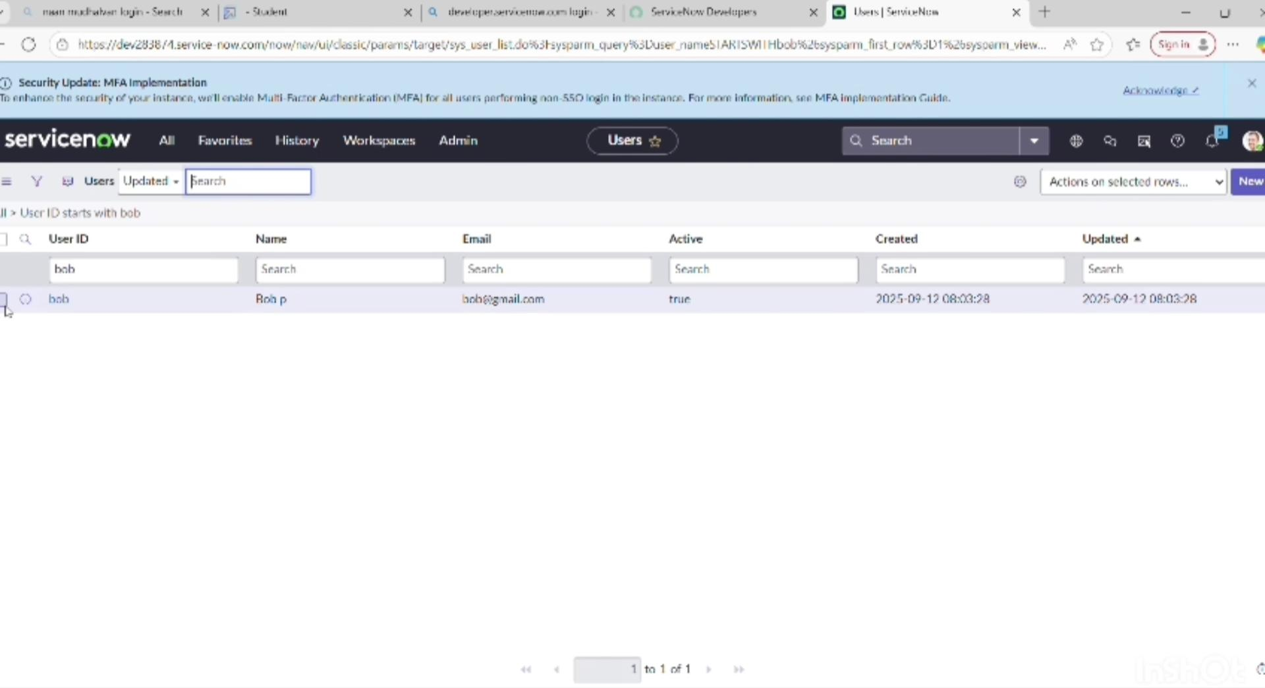

**Milestone 2:** Group

**Activity 1:** Create Groups

1. Open service now and select All
2. All > Groups
3. Select group under system security option and select new
4. Fill the given details to create group
5. 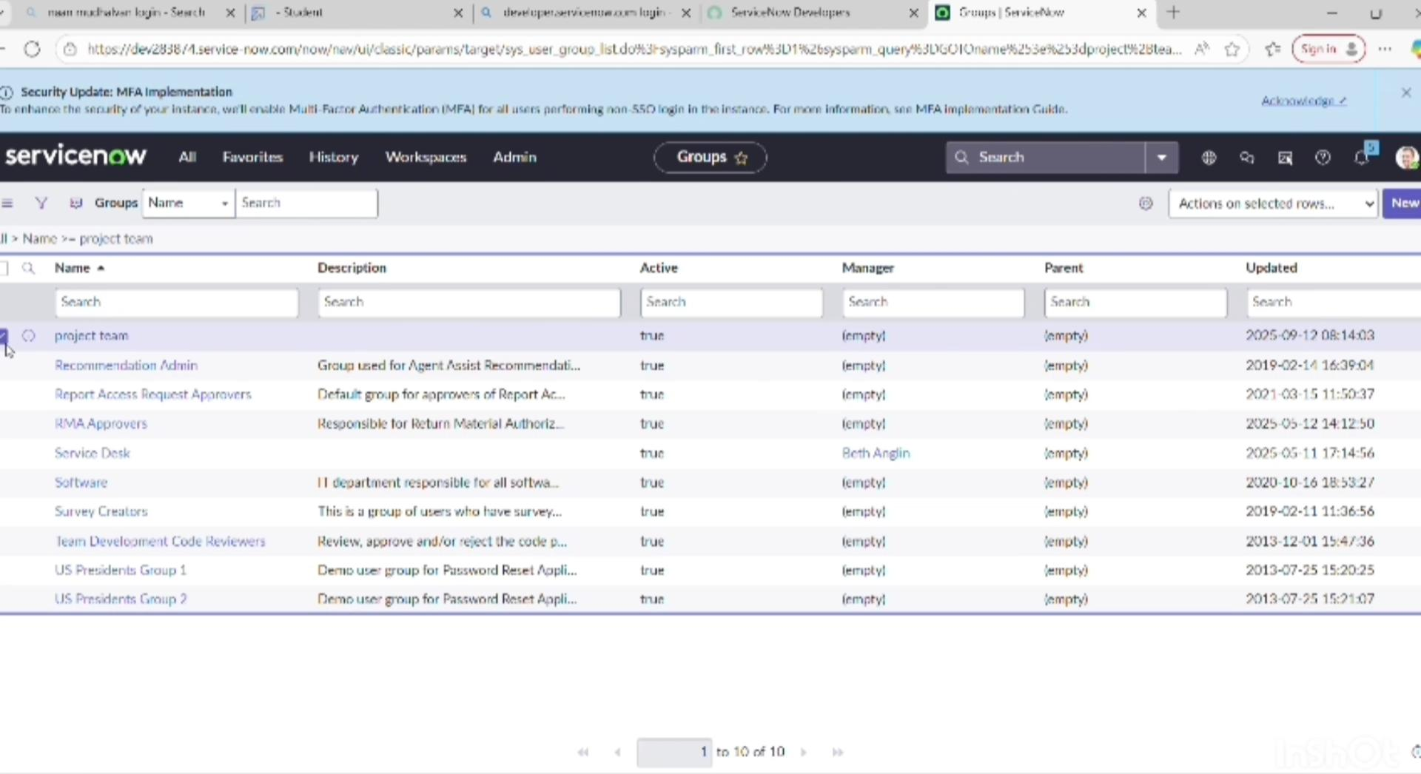Click on submit

**Milestone 3:** Roles

**Activity 1:** Create Roles

1. Open service now and select All
2. All > Roles
3. Select Roles under system security and select new
4. Fill the required details to create a new role and click submit
5. Create another role with given details
6. Click on submit

**Milestone 4:** Table

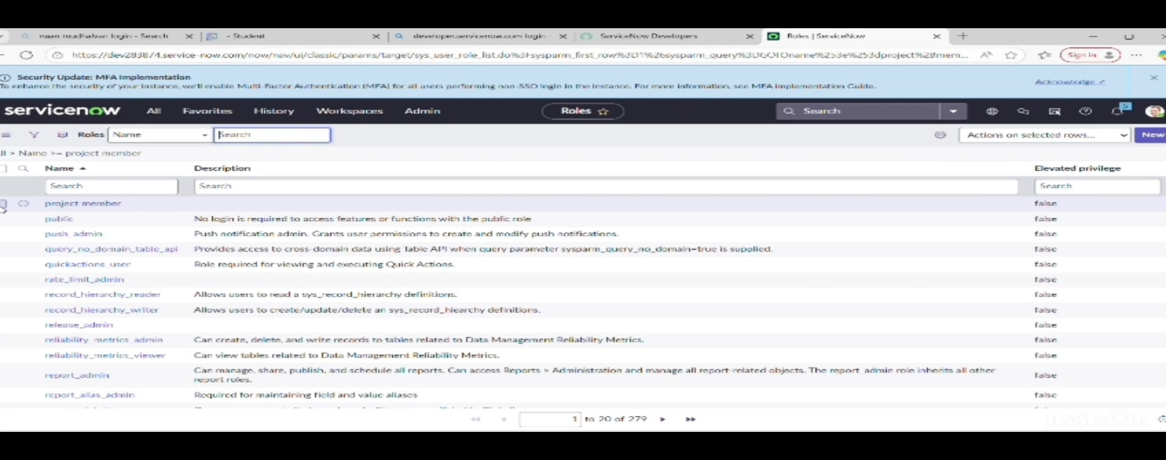**Activity 1 :** Create table

1. Open service now and select All
2. All > tables
3. Select table under system security and select new
4. Create a new table name “ project table “ and click on submit
5. Create one more table name as task table 2 and Fill the required details
6. Click on submit

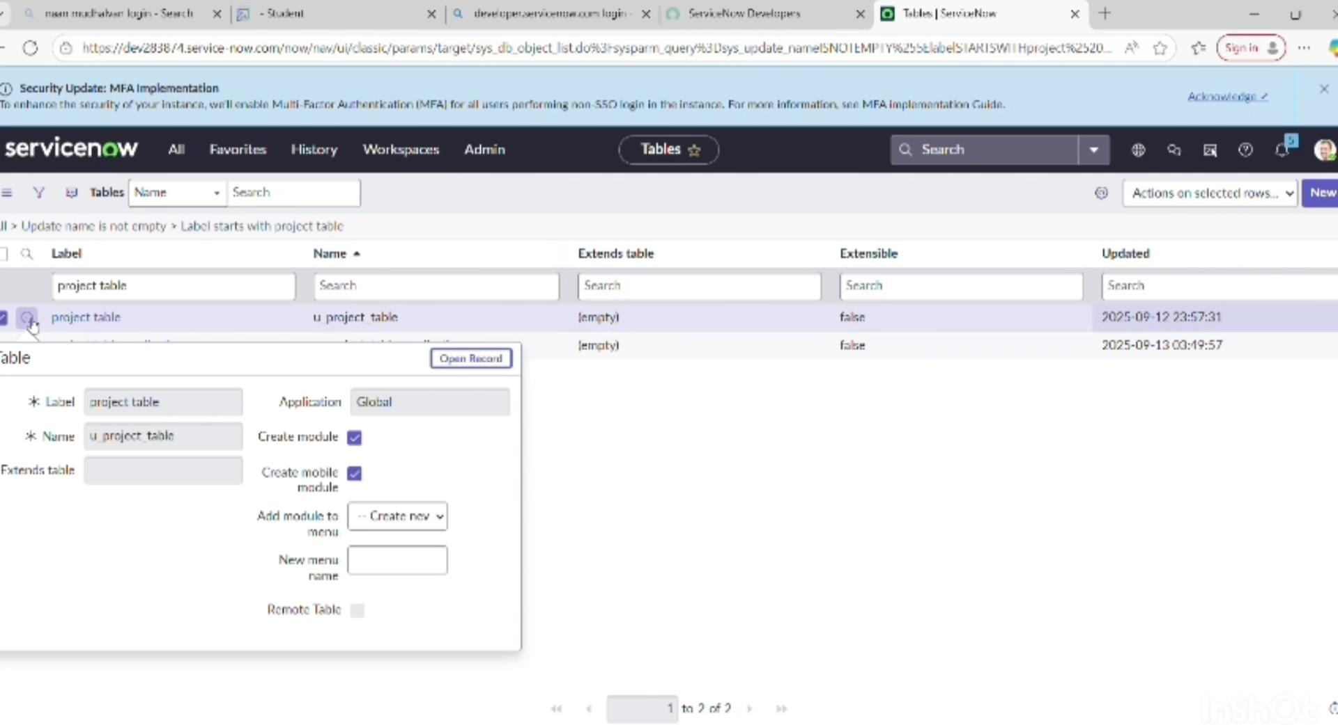

**Milestone 5:** Assign Users to Groups

**Activity 1:** Assign Users to project team group

1. Open service now and select All
2. All > Groups
3. Select tables under system definition and choose project team group
4. Click edit under group member
5. Select Alice p and bob p and then click on save

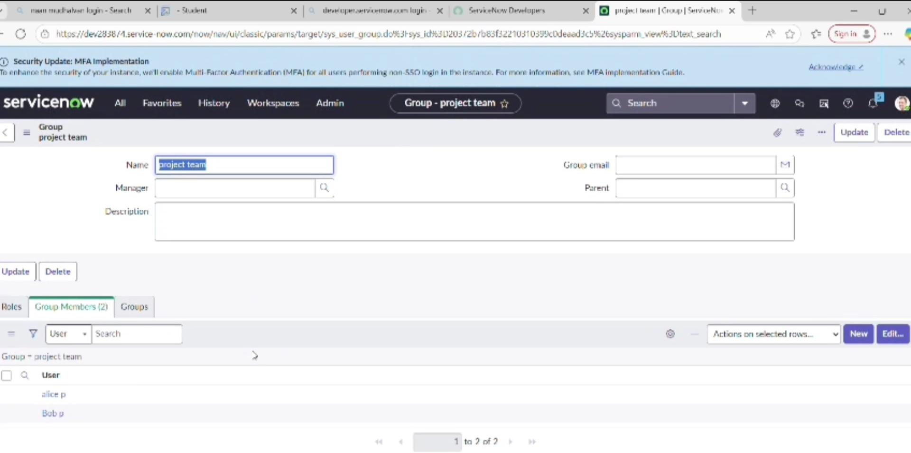

**Milestone 6:** Assign Roles to Users

**Activity 1:** Assign Roles to Alice user

1. Open service now and select All
2. All > User
3. Select table under system definition and select project manager user
4. Select edit and select project member, click on save
5. Edit add u_project_table role and u_task_table role
6. Click save and update the form

**Activity 2:** Assign Roles to bob user

1. Open service now and select All
2. All > User
3. Select tables under system definition and choose bob user
4. Under team member Select edit
5. Select team member and give the role
6. 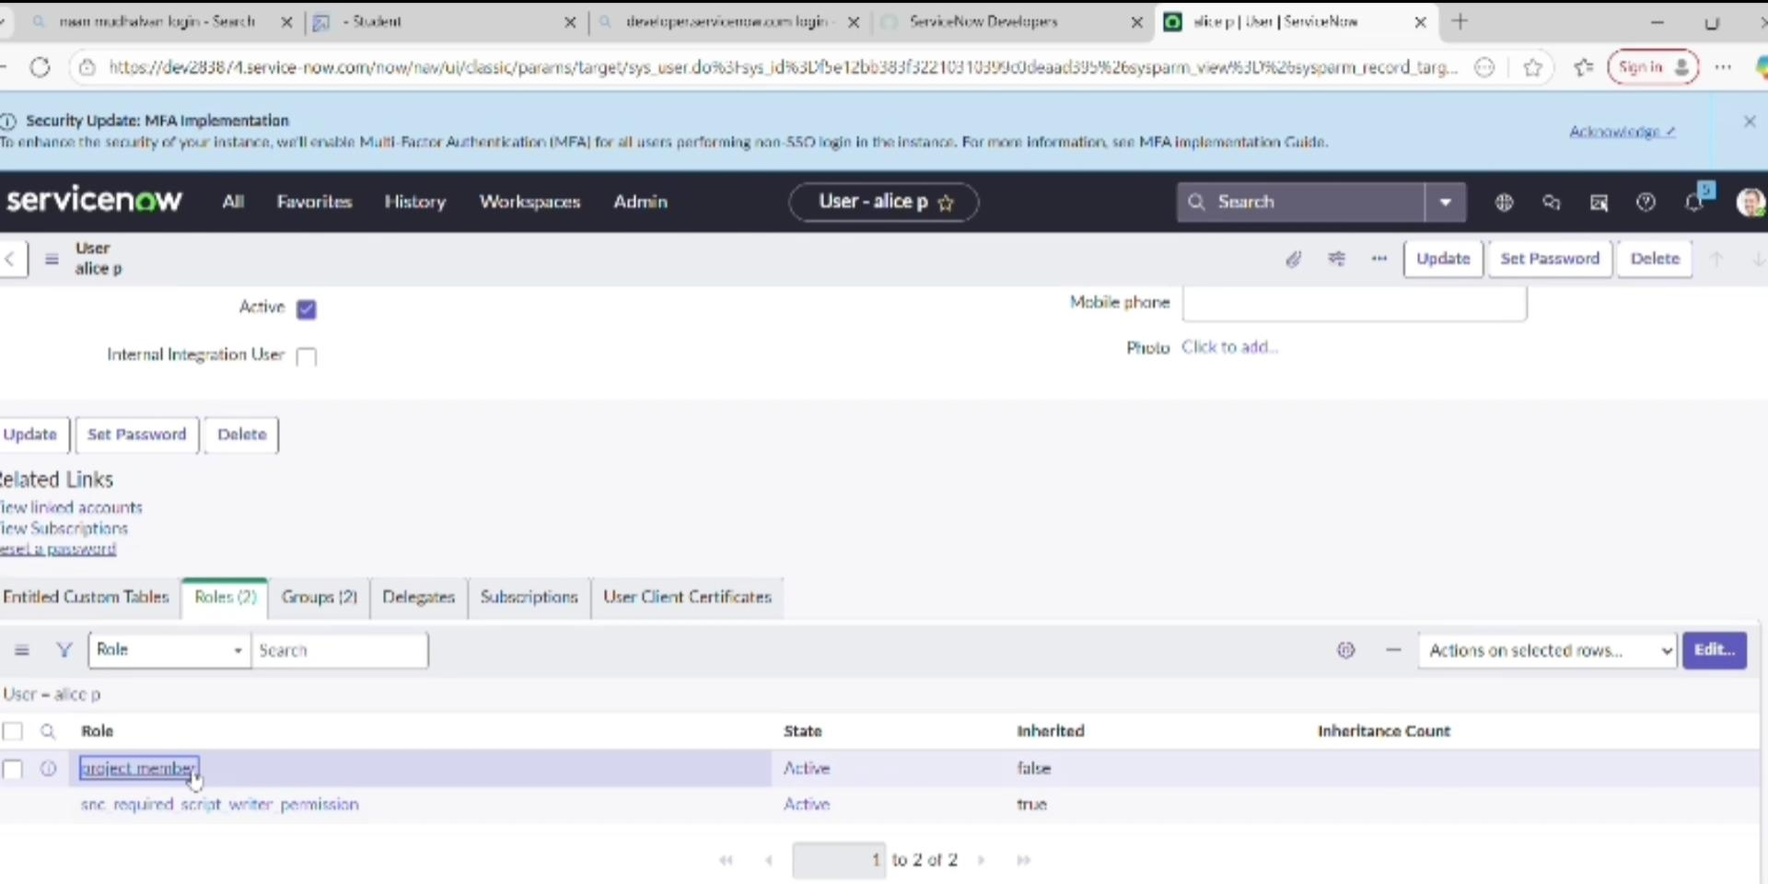Click on profile and change impersonate user to bob to see task table 2.

**Milestone 7:** Application access

**Activity 1:** Assign table access to Application

1. In application navigator search for project table application
2. Click on edit
3. Give project member role to the application
4. Search for task table 2 and select edit application
5. 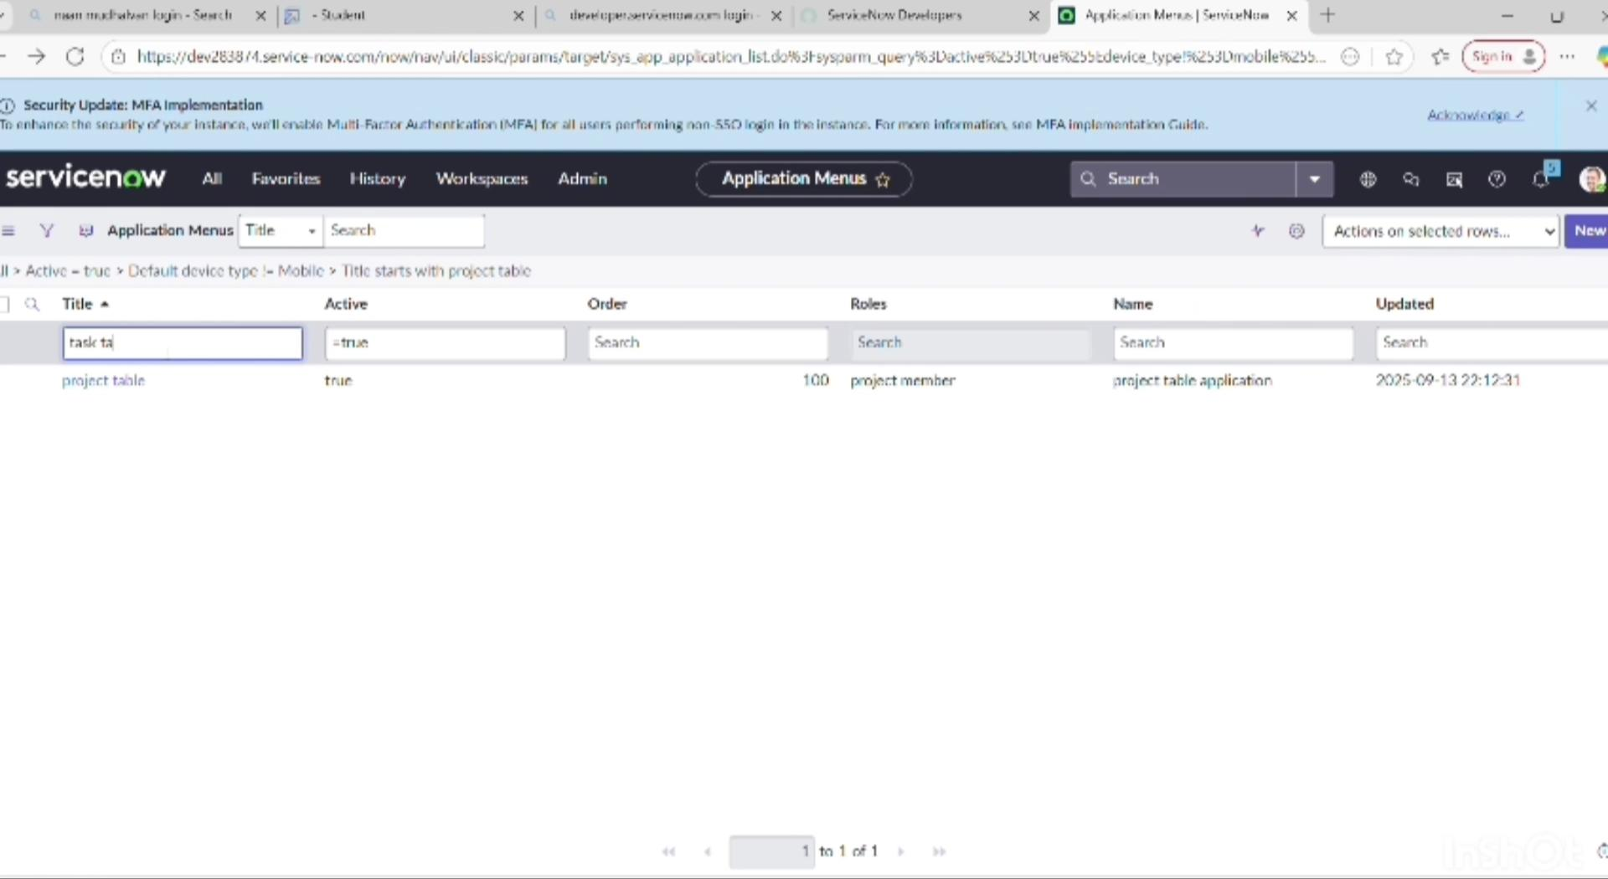Select project member and team member role for task table 2

**Milestone 8:** Access control list

**Activity 1:** Create ACL

1. Open service now and select All
2. All > ACL
3. Click elevate role and new
4. Fill the details and create a ACL
5. Double click on insertva new row and give task table also team member role
6. Click on submit
7. Create 4 ACL and click on profile on top right side
8. Click on impersonate user and select bob
9. Select task table 2 in the application menu bar
10. Comments and status field are have edit access

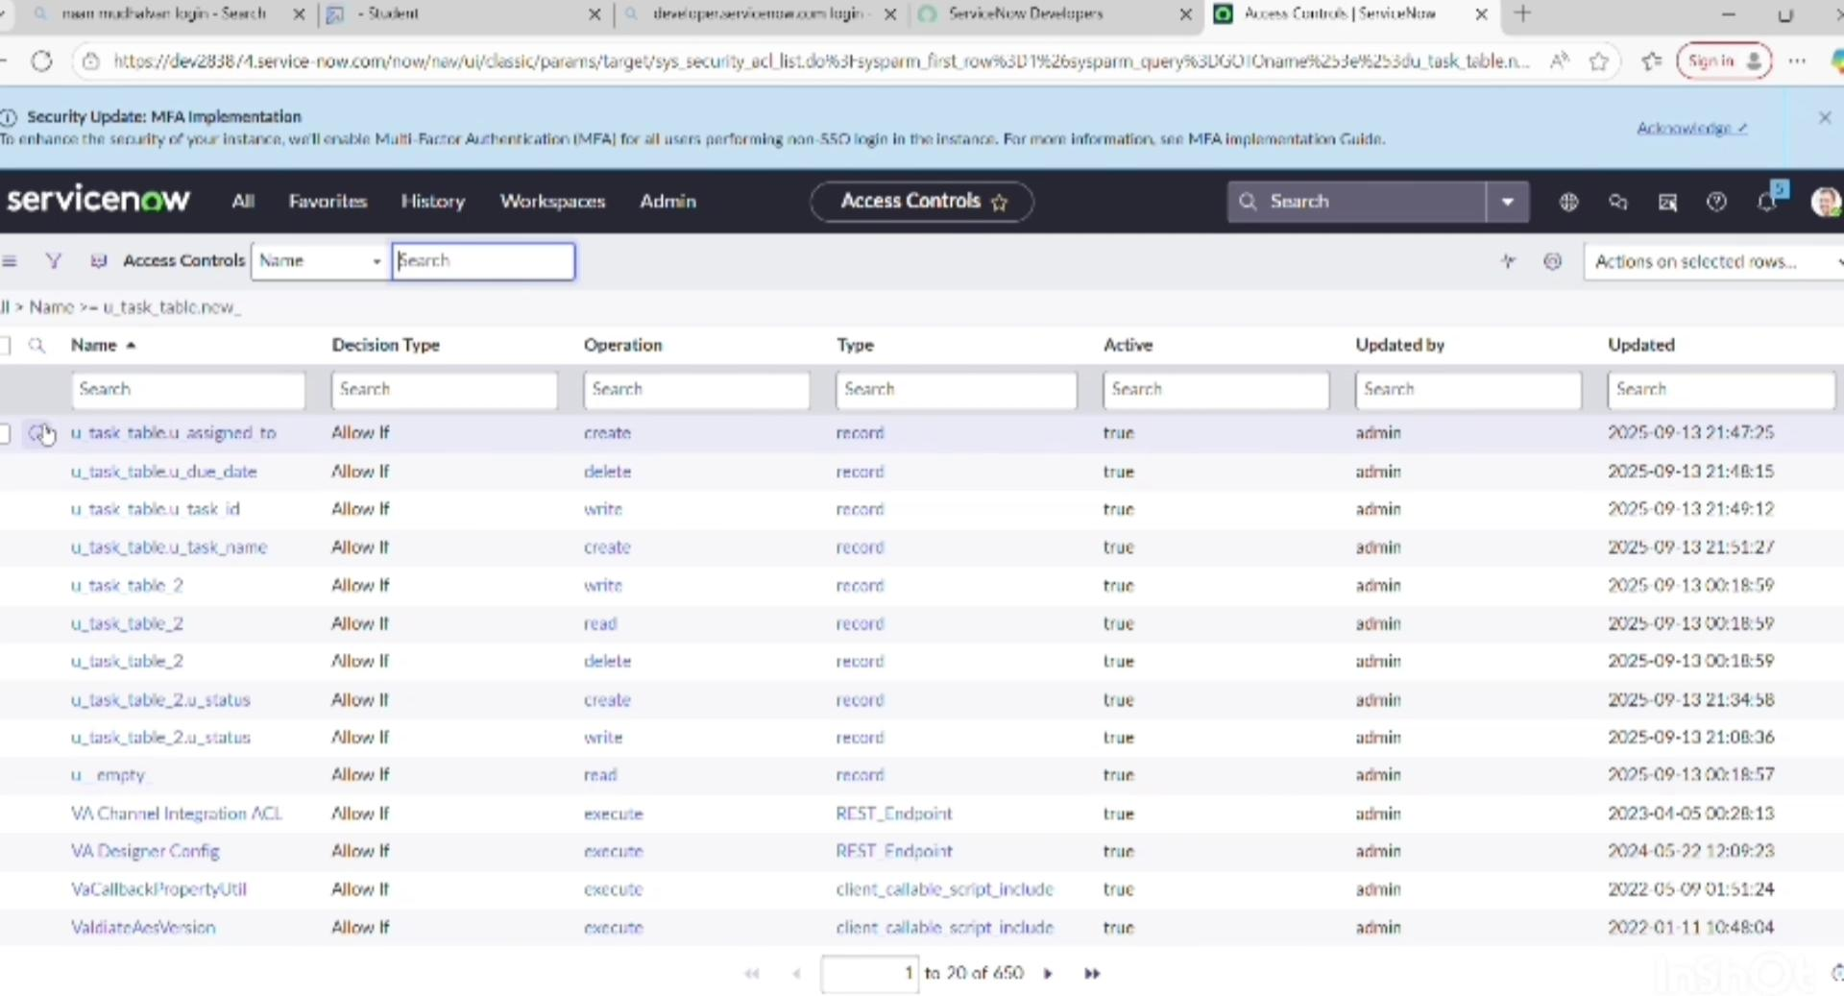

**Milestone 9:** Flow

**Activity 1:** Create a flow to assign operations ticket to group

1. Open service now and select All
2. All > Flow Designer
3. Click on new and select flow
4. Give flow name as “ task table “
5. Applications shoul be global and select build flow
6. Click on Add a trigger
7. Search for “ Create record “ and select
8. Give the table name as “task table”
9. Give

Condition as field: status operator : is valueb: in progress

Field : Comments operator : is valuev: feedback

Field : assigned to operator: is value : bob

10.click on done.

11.click on action

12.search for update records

13.drag the field from the Dara navigation

14.Add field as status and value as completed

15.click on done

16.click on Add action

17.search for ask for approval

18.In record field drag the field from the data navigation

19.Give the approve field as status and give approver as Alice p and click on done

20.Go to Application Navigator and search for task table and update it status field to completed

21.In Application navigator search for my approval and click on my approval.

